https://www.facebook.com/BikeAcrossCanadaRouteNetwork/posts/pfbid02DgA6SJy31A8hZoEw3jzzKjHQuofWPrsgRifdJySs482SKgvmqym53uEZMRntWLNsl
Currently, when loading a KMZ file to Organic Maps offline maps, the default that all points in the loaded file show up as red placemarker with a white star.
Here's the process for batch editing a selection of the points in the KMZ file to be a different colour and show up as a different icon.
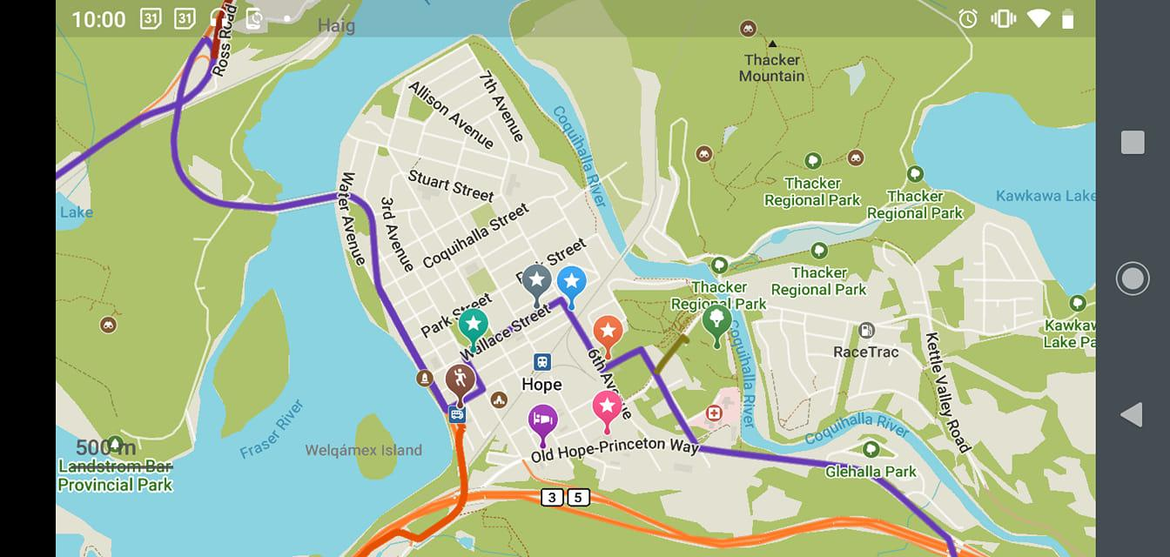

In this example, we will use the working GPX file using Garmin MapSource to start with (Garmin Basecamp uses the same filetype and works the same way).
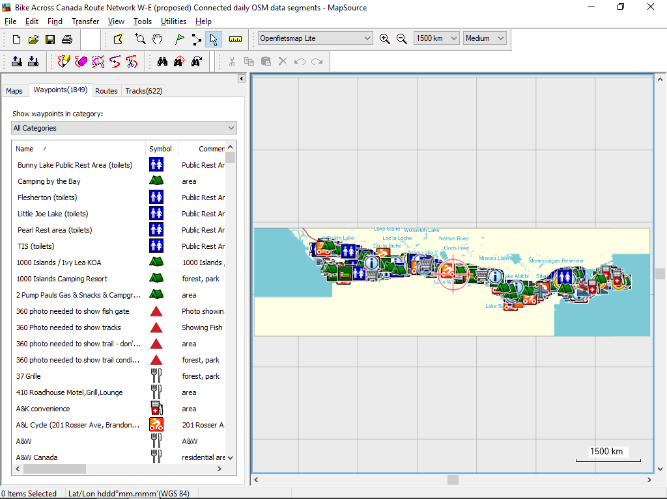

The Waypoints in the file are organized into 16 categories. I selected the 3rd one which I've named 'Rest Areas w/ wc' (toilets); it now shows only these placemarks in the list.
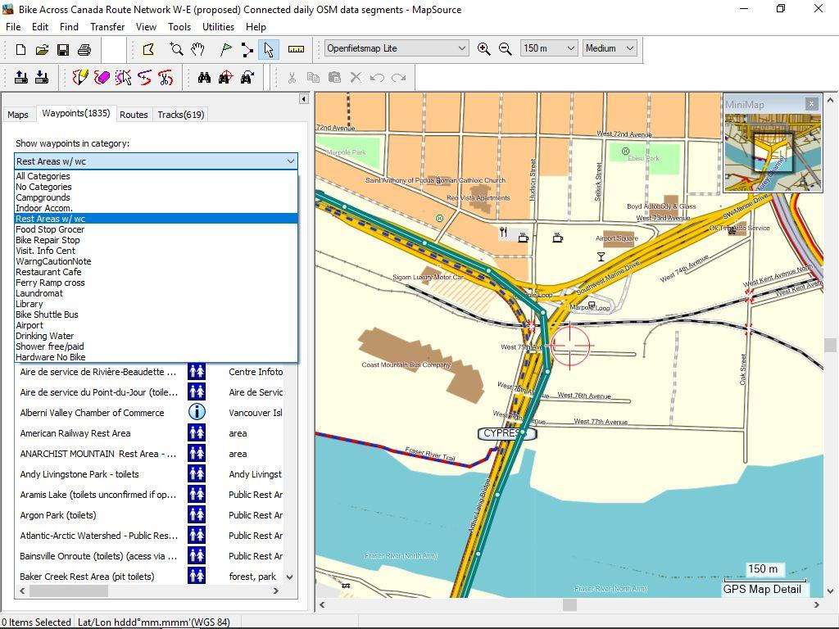
I now select all of the points in the list, and copy/paste into a new map document. (File > New)
and SaveAs a filename with the current date, as this is one-time an extract of the document (as this document is constantly changing) and save it as a 'GPX file' in a folder that is appropriate.
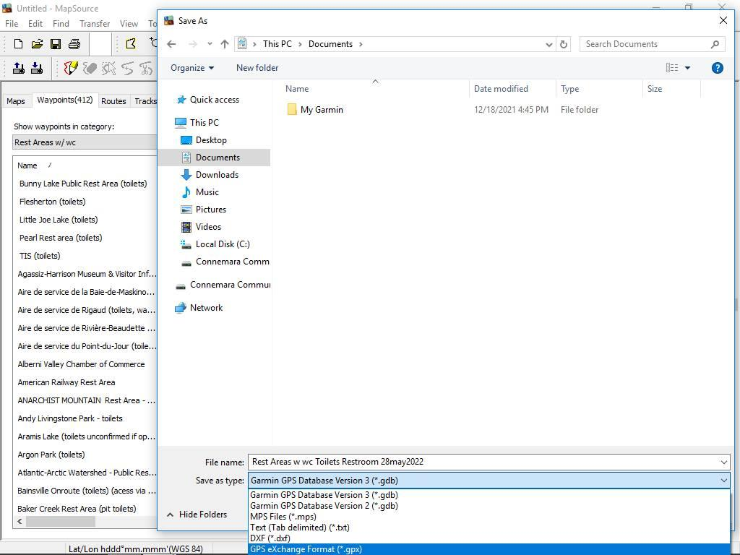
Next, i open up the Google Maps map with the old data of the Toilets list, as this one is better (more points listed) and make a new layer, and click on 'import' (it will open GPX files)
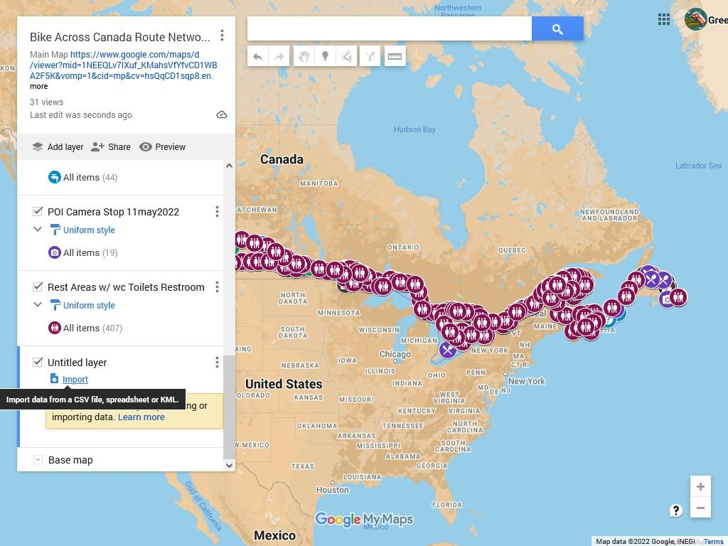
I change the layer name to remove the .gpx as it's confusing and change it to Uniform Style and set the icon to the same as the old layer, and then delete the old layer.
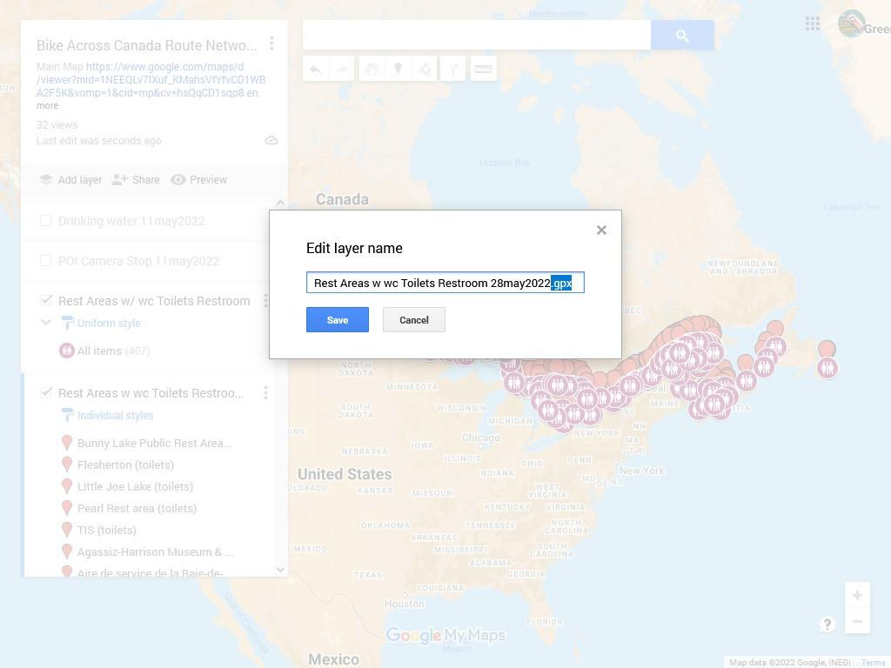
Then over on the smartphone, I open up the Google map with Google Chrome mobile browser (it probably would work with other browsers)
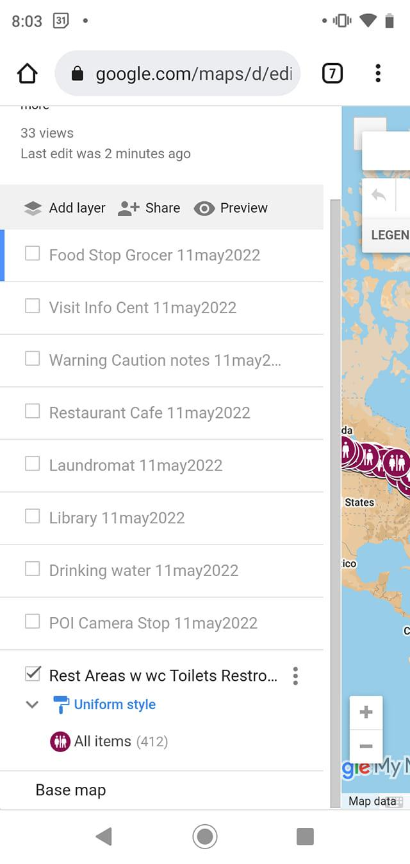
I then export the data from that layer as KMZ (from clicking on the 3 dots for options)
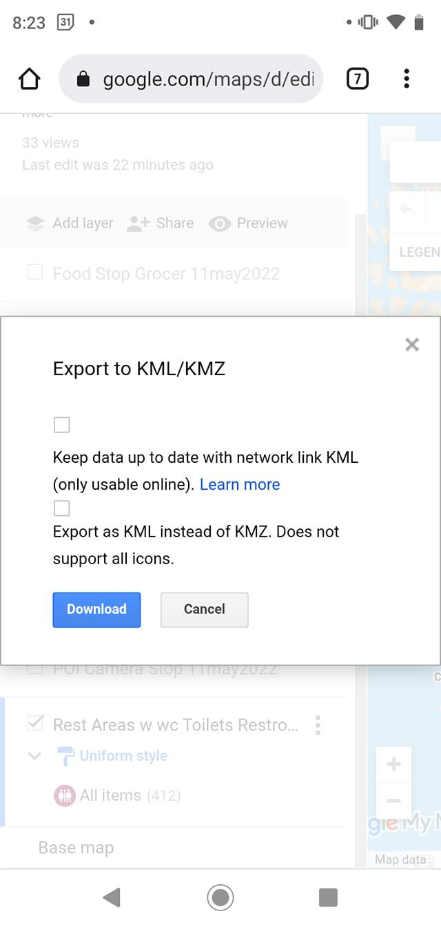
I then download the KMZ file and open it with the Organic Maps offline maps it should load as a 'bookmark' layer at the top of the list.
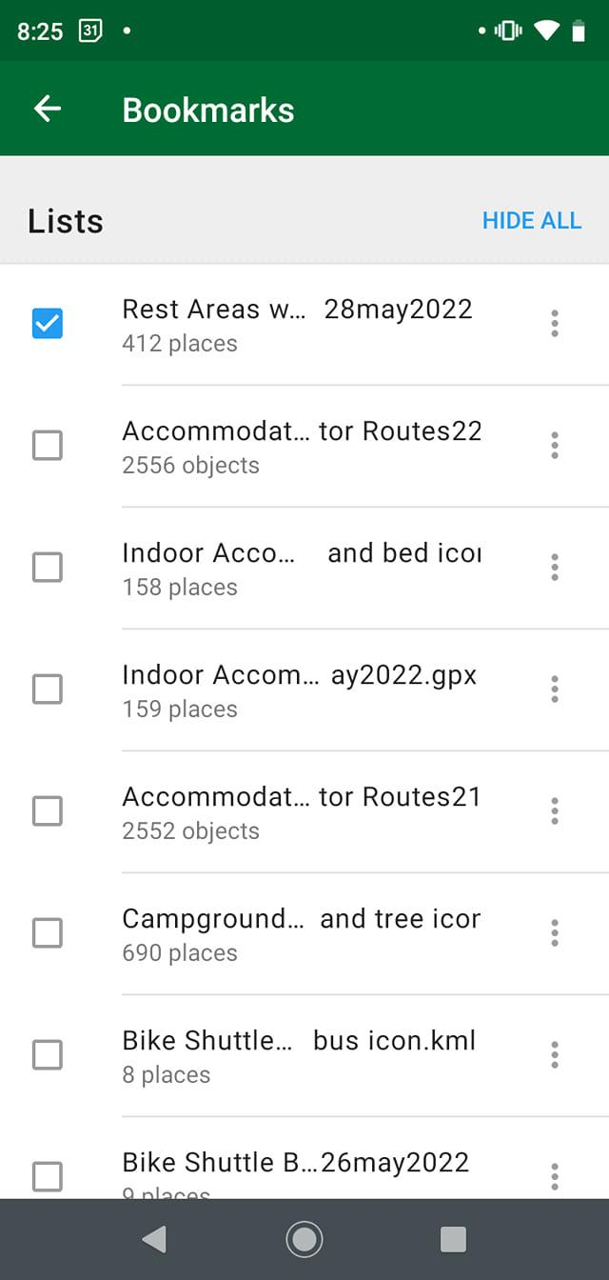
You can see that the points are all red
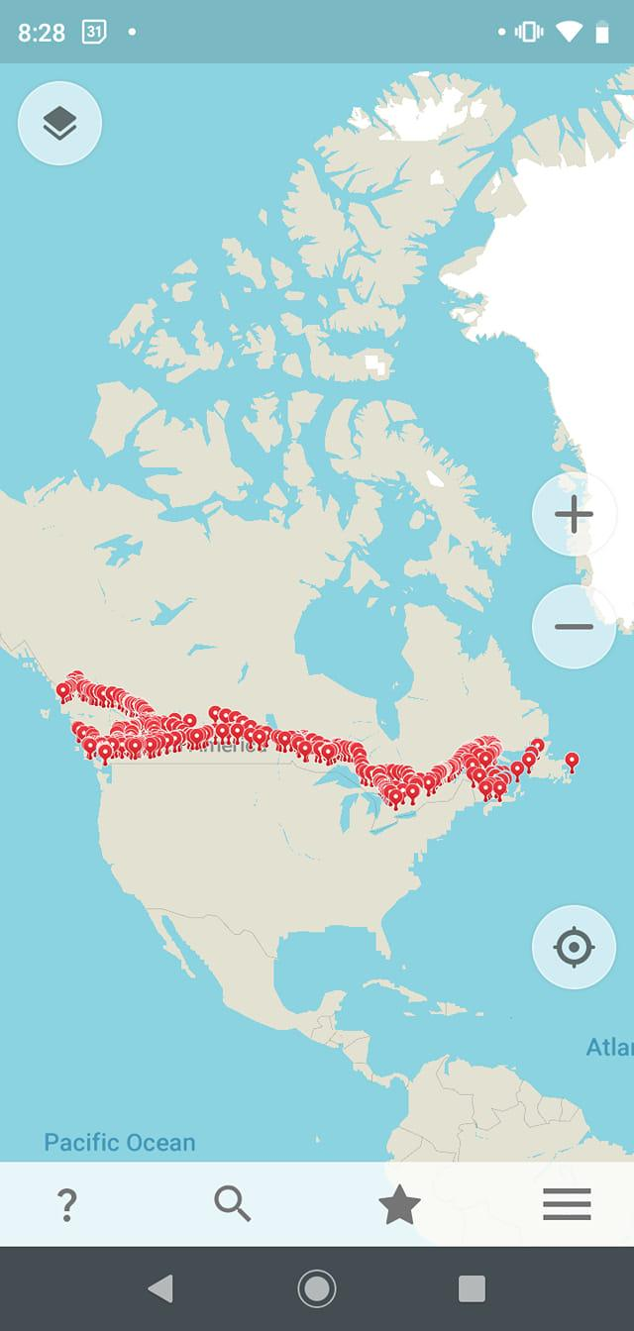
And when you zoom in to 500m or more, you see the icons are the default white star.
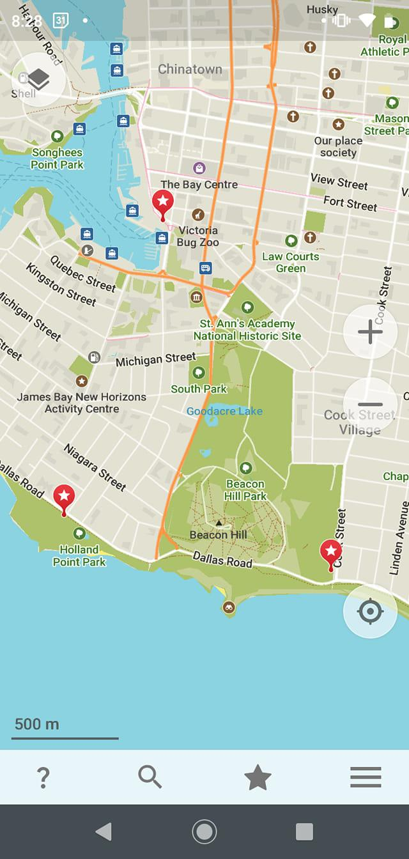
Then add in a placemarker with the icon you want, and the colour you want it to be and add it to the same bookmark layer we are working with.
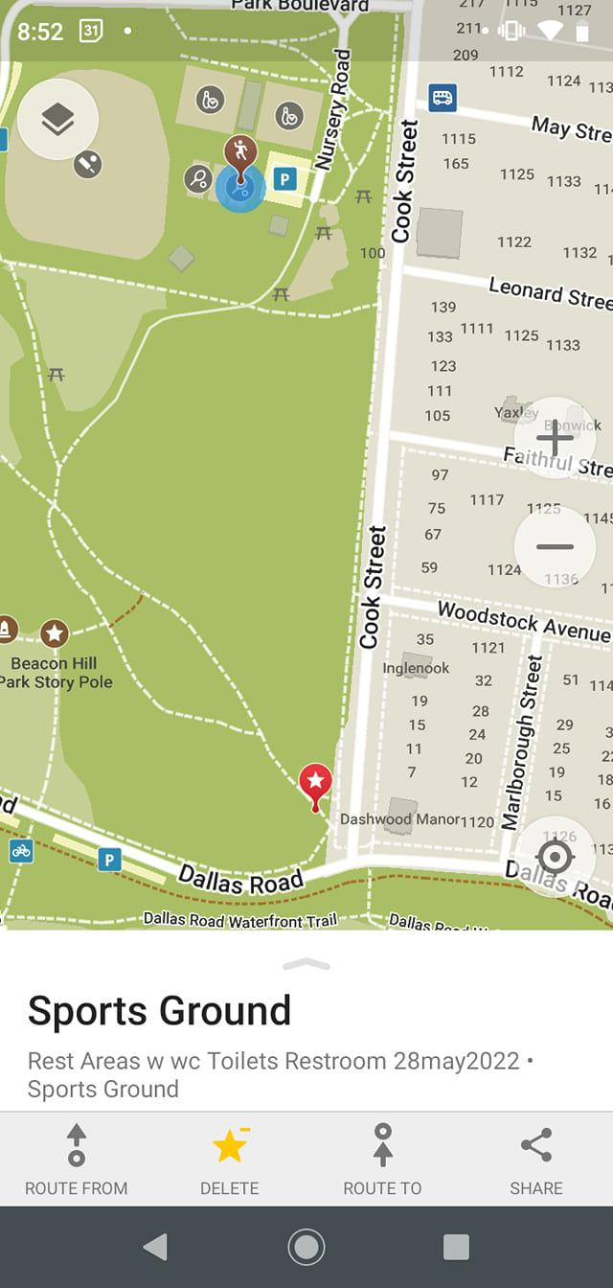
The next step is to email it to yourself, it automatically generates the text of the email and the subject as the attachment of the KMZ file.
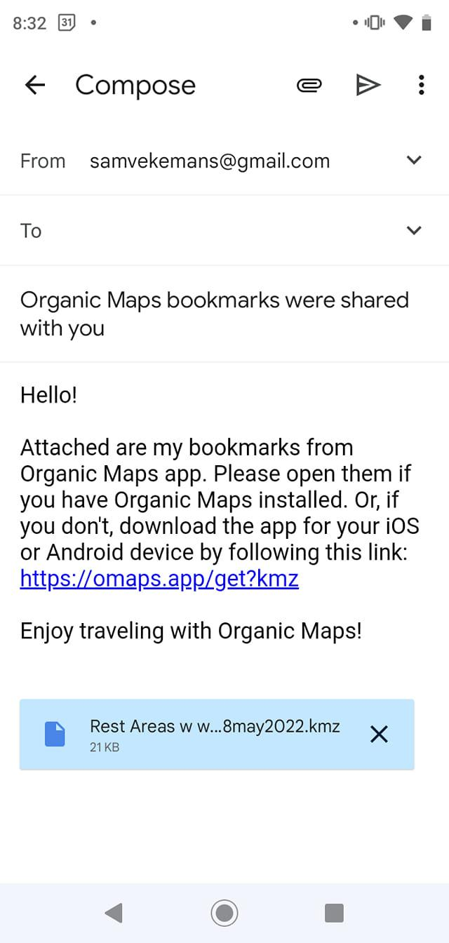
Then, on the desktop, I download the file to somewhere nice, open up the KMZ file with Google Earth.
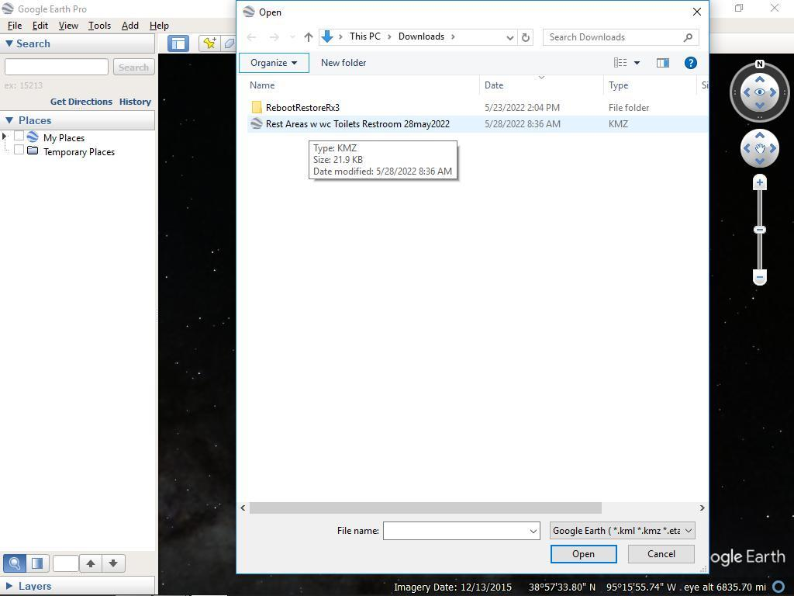
Then I right-click on that layer in Google Earth, and Save Place As, and select KML type (it's fine to use the same file name, as it's going to be changed anyway)
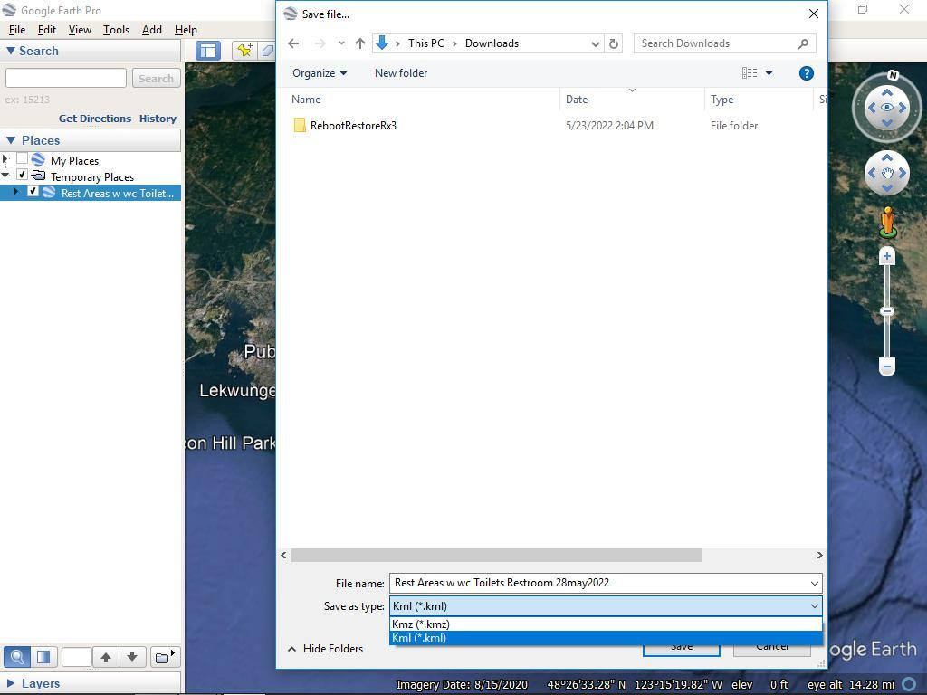
Then using Windows Notepad, open up the KML file, (it looks kindof like HTML code)
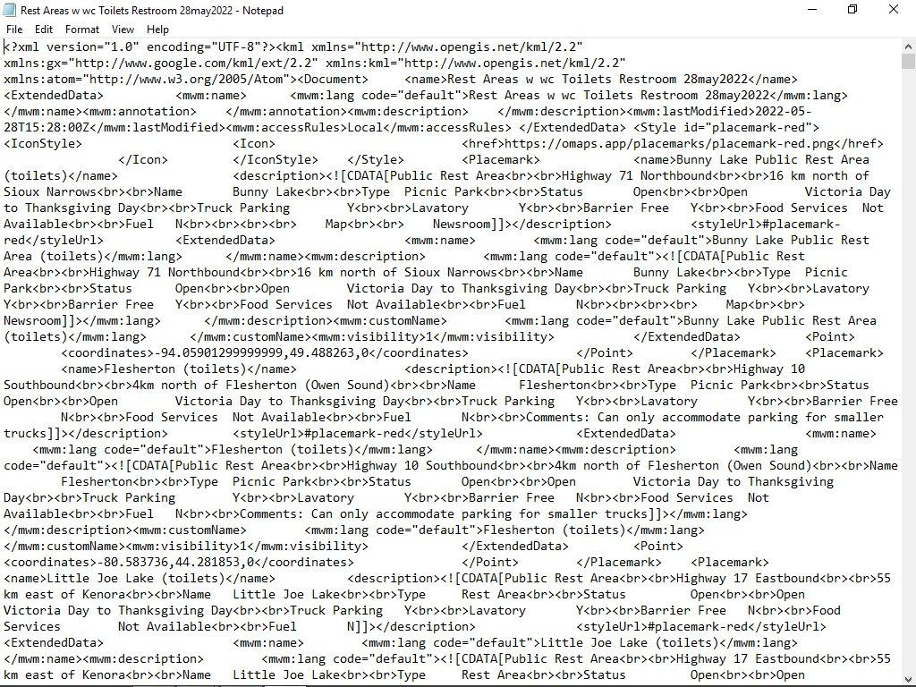
The next step is to find/replace 'placemark-red' with 'placemark-brown' so then all the points in the file will show up as brown instead of red.
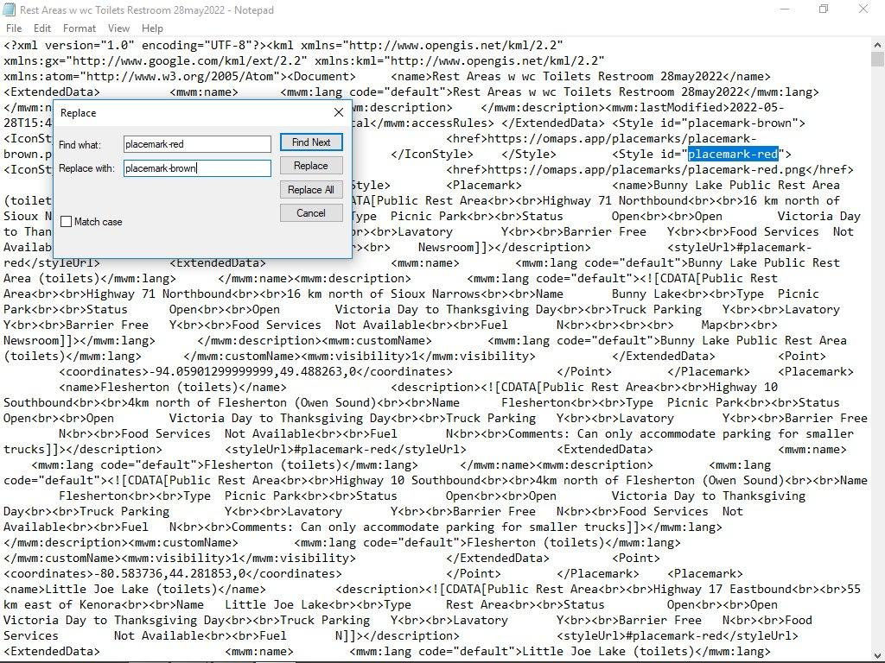
The next step is to, in Notepad, Edit>Select All and Edit>Copy
and then go to your webbrowser with Google Drive, then make a New > Google Docs > Blank Document
and then 'Ctrl+v' (paste)
it might take an actual minute to paste all the text of the file to this document.
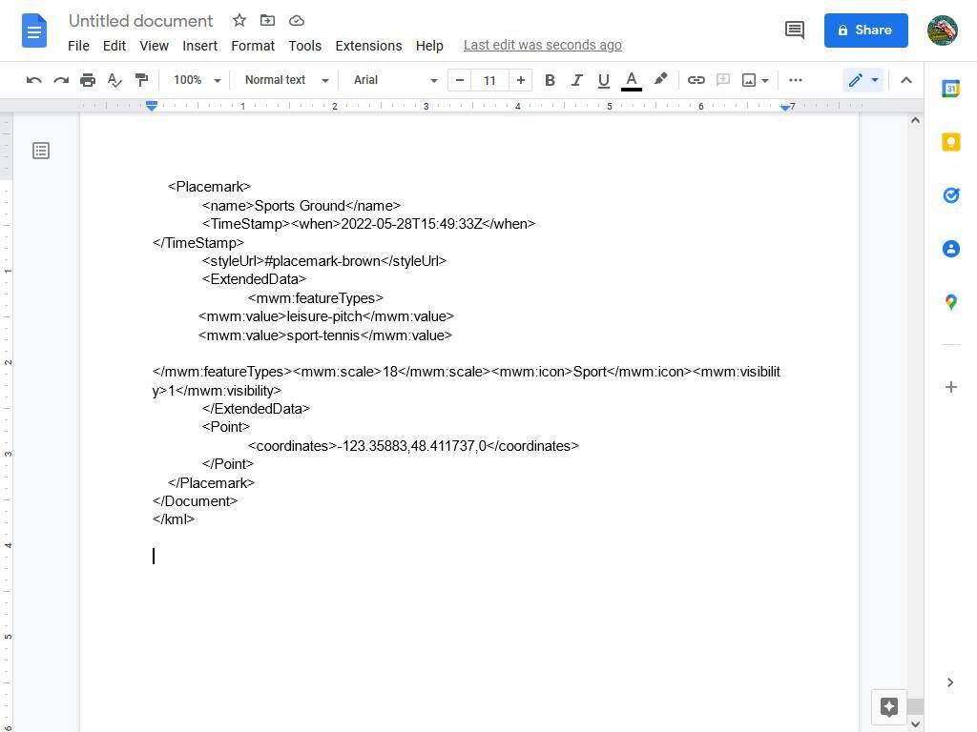
This is the part we are interested in, select it and press 'Ctrl+c' (copy)
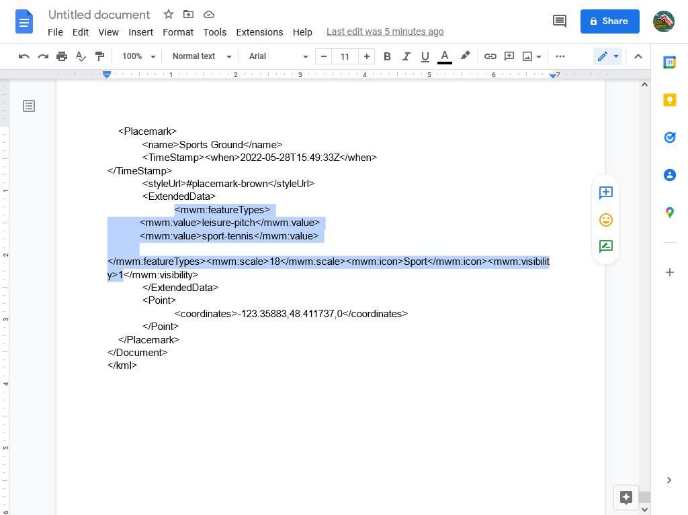
Then 'Edit' and 'Find/replace'
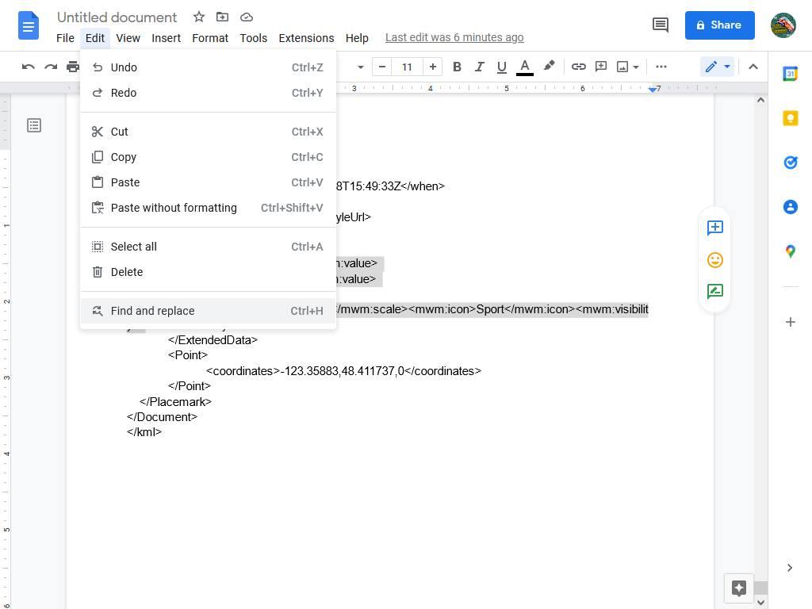
Then in the top part 'Find' have
<mwm:visibility>1
and in the bottom part 'replace' have
<mwm:featureTypes> <mwm:value>leisure-pitch</mwm:value> <mwm:value>sport-tennis</mwm:value> </mwm:featureTypes><mwm:scale>18</mwm:scale><mwm:icon>Sport</mwm:icon><mwm:visibility>1
What this will do is look for anywhere in the document that has the visibility 1 tag and replace it with the same thing but include the feature type, value, scale and icon tags before it. In this example, all of the placemarkers in the file will be changed to have the 'sport-tennis' tag and the icon 'Sport' (a person running - to the washroom, Organics Map doesn't have any other suitable icon for it, so this is the best option. Another option is a House or building icon which doesn't fit.
Then click 'replace all' and let it do it's magic.
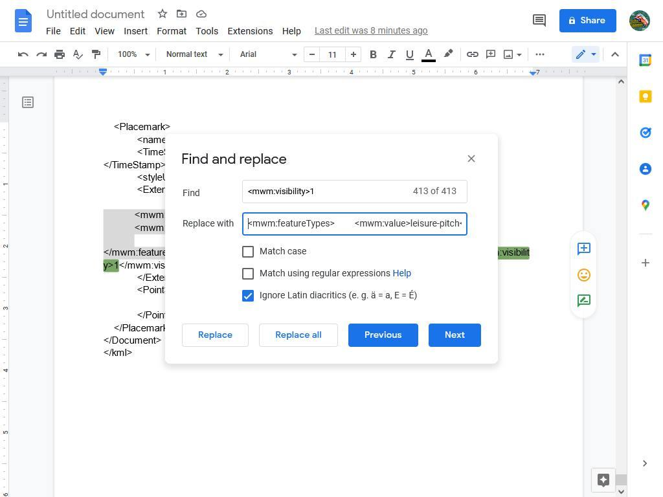
Then you want to select the last placemark and delete it as it's no longer needed.
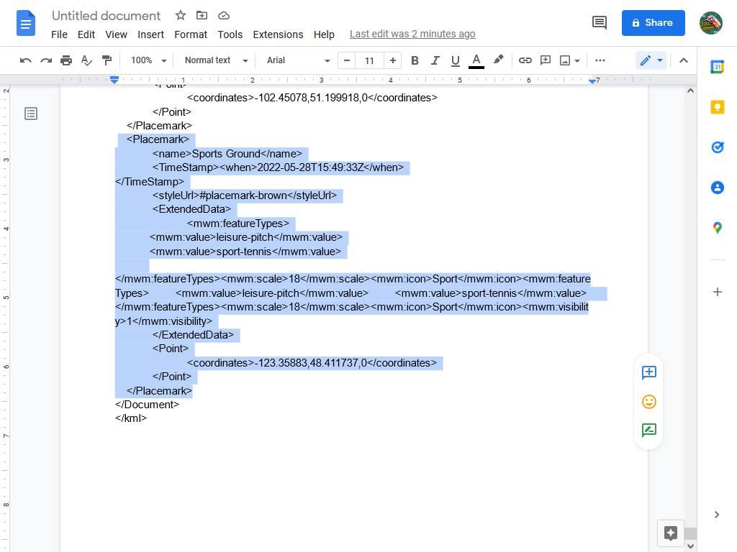
Then you want to select all (everything in the document) and press 'Ctrl+c' (copy)
then go to windows notepad open document, and delete all the text in it.
Then 'Edit>Paste' and the new modified text will show up.
Then you want to change the name internally of the KML file to reflect these changes, so add in ' placemark brown and running icon'
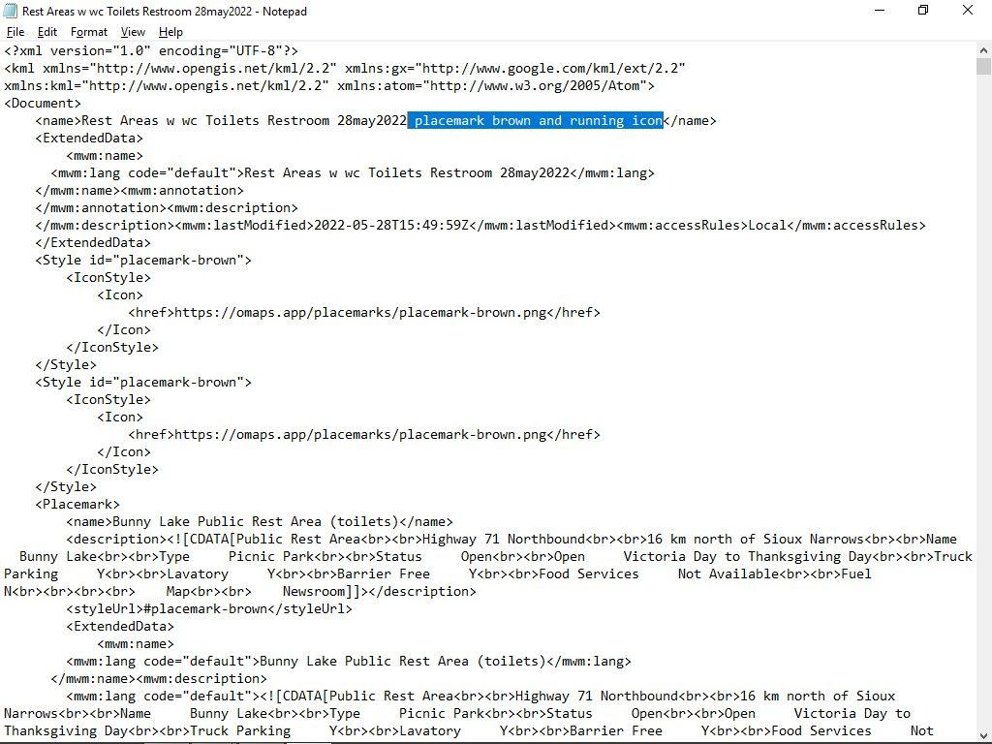
and again deeper in the magic code so it will recognize it.
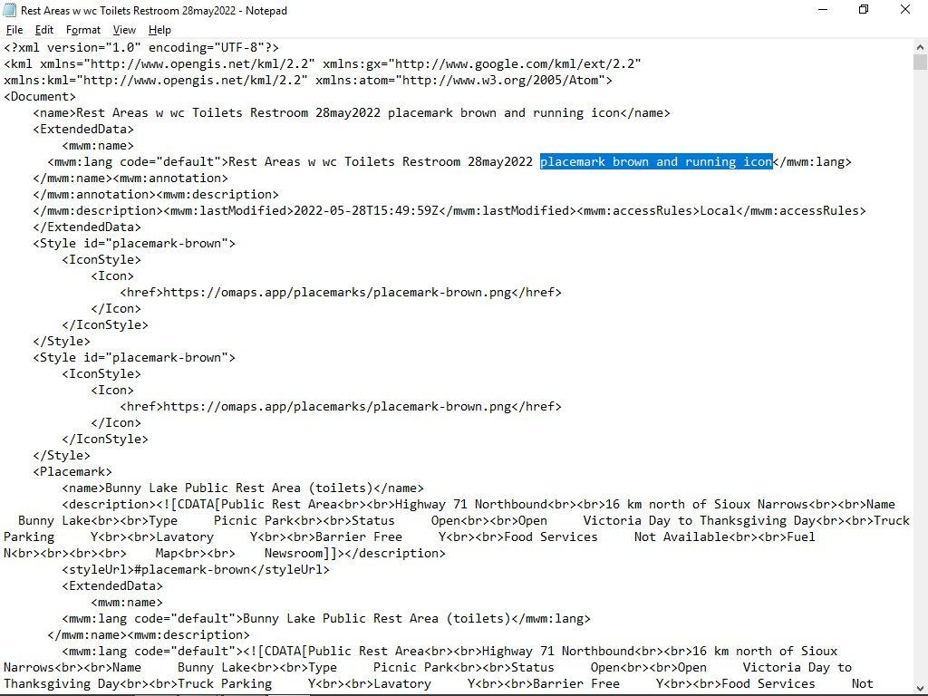
Then you want to save this as a KML file with the additional text in the name, and 'Save a type' (All files) so then it wont save as a .txt file.
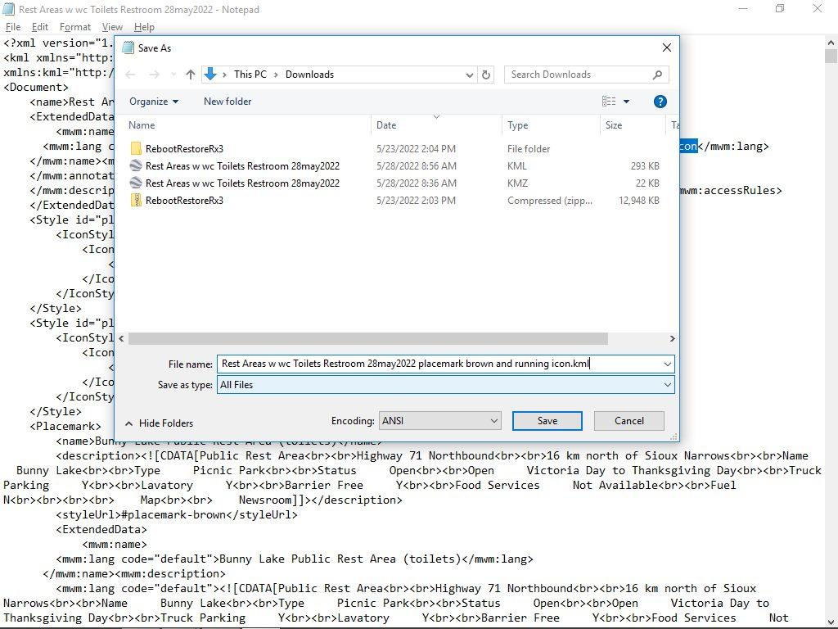
Then you want to go into Google Earth and open that KML file
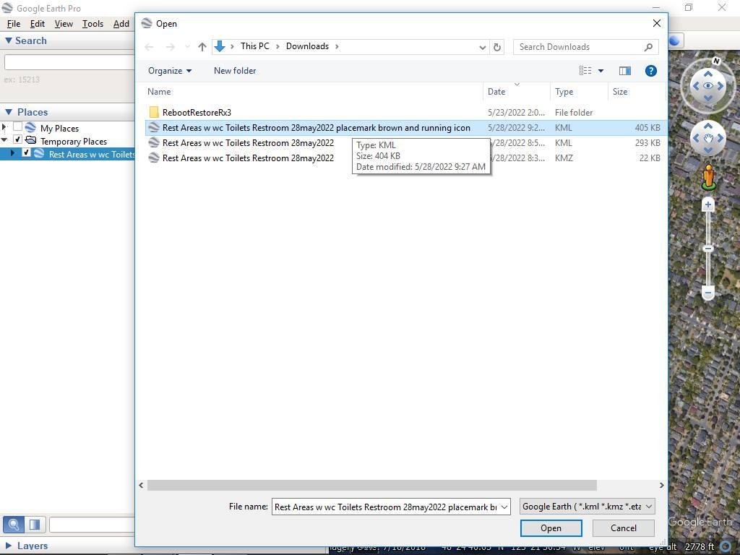
Now you should see them all show up as brown icons on Google Earth.
Right-click on the layer and 'SaveAs' and select 'KMZ' so it saves as a KMZ file.
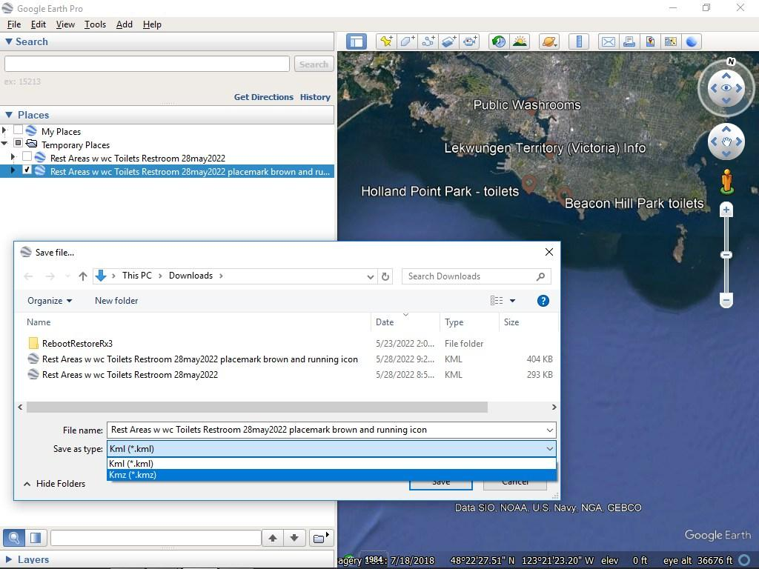
Then i want to email the KMZ file to myself with an appropriate subject and body so i can remember it.
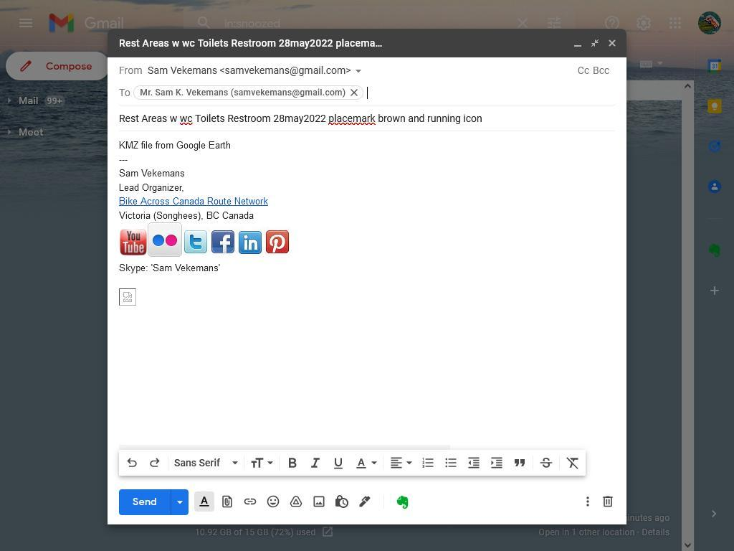
Then i open the KMZ file in Organic Maps app, and hide the previous bookmark layer and you should see all the toilets are now brown with the running person icon. :)
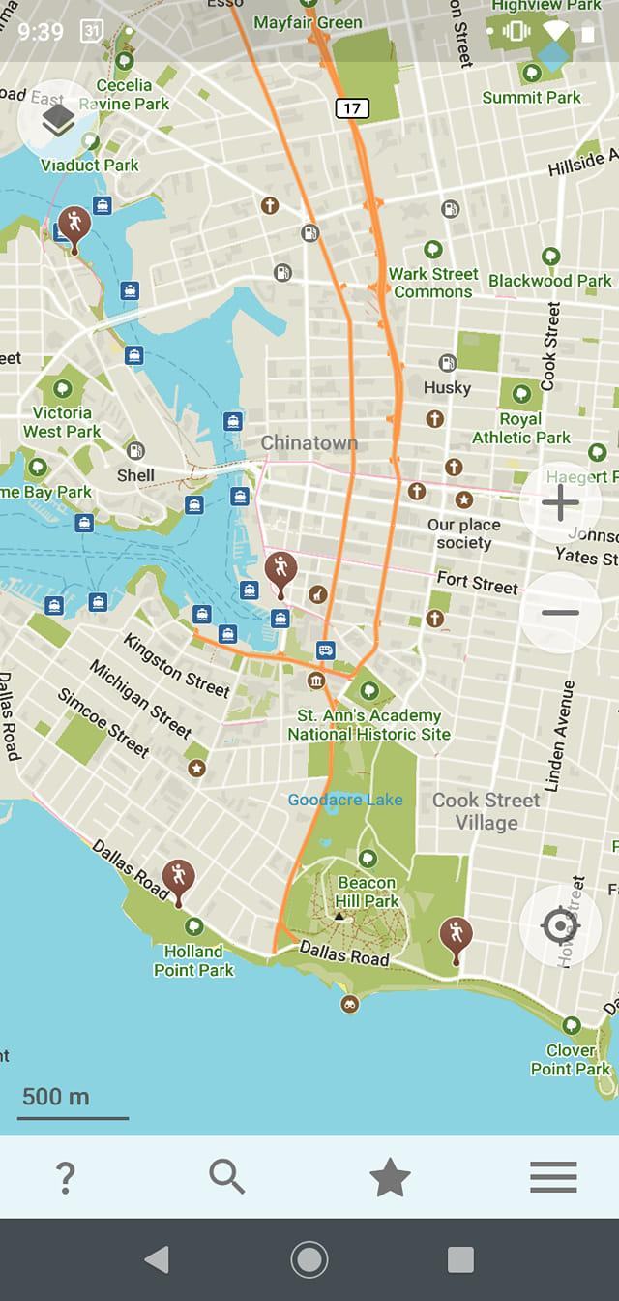
I then download the most current public copy of the KMZ file hosted on Internet Achive and open the file with Google Earth
'Bike Across Canada Route Network KMZ - extracts from GPX file.kmz'
https://archive.org/download/BikeAcrossCanadaRouteNetworkGPSTracksPOIs
I then select the new version of the Rest Areas w wc toilets file and bring it into the large KMZ file directly under the old one.
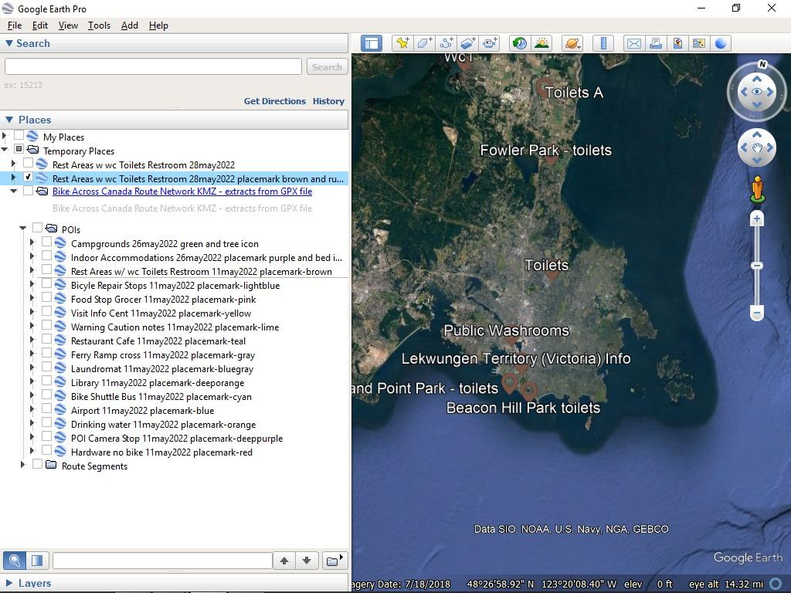
Then i delete the old layer of Rest Areas, and save the file overwriting the downloaded version.
Then i upload and replace the file on Internet Archive so everyone can see it I could also email the updated KMZ file to myself and open it in Organic Maps app to confirm it works.
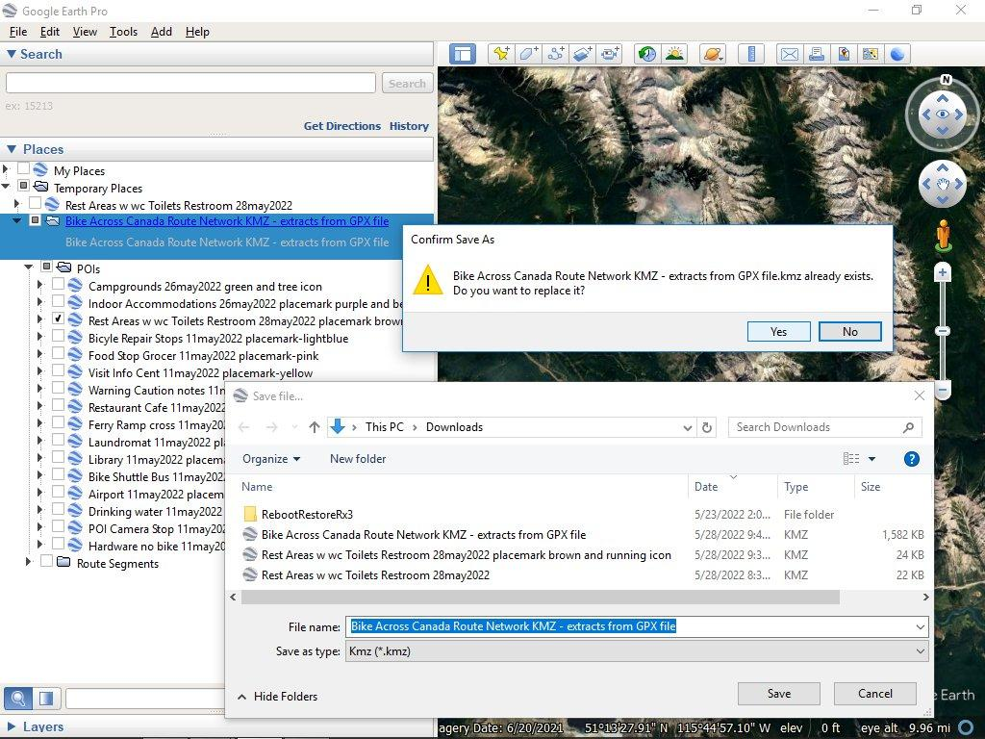
And here's the updated KMZ file showing the brown icon with a person running to represent the toilet.

